Guidelines to format papers for TensiNet Symposium 2023
Corresponding AUTHOR*, Forename B. SURNAMEª, Another AUTHOR^{b}
*Affiliation of Corresponding Author
Address of Corresponding Author
Email Address of Corresponding Author

ª Affiliation of another author if different from Corresponding Author
^{b} Affiliation of another author if different from other authors

Abstract
This document contains information about the desired format of papers for single-blind peer review and publication. They must be written in English and should be laid out on A4 paper size. You can produce your paper by simply replacing the contents of this file. Submit both the source file (.docx file format) and the PDF document (.pdf file format). Although manuscripts will be peer-reviewed and may be returned to the authors for revision before publication, initial submissions should be made in final form assuming that no revisions shall be necessary. Your abstract should be a single paragraph of text only (no equations, figures or special characters) and should be limited to about 15 to 20 lines of text in 12pt Times New Roman [Style: Normal].
Keywords: Include a list in 10pt Times New Roman [Style: Keywords] of between five and ten keywords or terms, separated by commas, using nouns or adjective(s)-plus-noun forms that are relatively standard in the field of lightweight construction. (For example: softening, lightweight structures, structural membrane, sustainability, performance, conceptual design, form finding, optimization, manufacturing)

1. Introduction
Manuscripts may be prepared using Microsoft Word, or another convenient editor provided the result follows the format of the file you are just reading and provided the result can be converted to a .pdf file. Please remember that your files should not be password protected or otherwise locked as the editors may need to make additional minor edits and formatting changes.
If you use Microsoft Word, please make use of this template (the file you are just reading). You can produce your manuscript by simply replacing the contents of this file and saving it as a Word document. You may need to adjust the format by specifically applying the Microsoft Word Styles within this document that have been assigned understandable style names, cited here within [square brackets].
The paper should be a minimum of 6 pages and maximum of 12 pages in length when formatted with this template. Make sure that the ratio of figures to text is well proportioned. Page limits for papers are strict, and authors violating them will be asked to make edits to reduce their paper lengths if necessary.
Papers will be published in electronic format as PDF files, so the use of color in figures and photos is possible and encouraged.

2. Layout of text
All text, figures and tables should be placed within this template maintaining the provided margins and layout settings. All elements of the paper are to be in the font Times New Roman. This sample file gives the basic layout, and the vast majority of the text, including the text of the Abstract, is in 12pt Times New Roman justified full [Style: Normal].
Please do not modify or write in the headers or footers, except for inserting the names of the authors in the first-page footer as indicated.
The paper should start with the Times New Roman 16pt bold title of the contribution as exemplified above [Style: Title]. The title should have capital letters only at the beginning of the first word and for proper nouns or acronyms. Next are the names of all authors in 12pt [Style: Authors] and in 10pt the affiliation of the authors [Style: Affiliation].
Please mark the corresponding author with an asterisk. Use all capital letters for the surnames of all authors, precede the surname by the forename, and provide full first forenames rather than only initials. Indicate the affiliation of the corresponding author using the asterisk and the affiliations of other authors using superscript lower-case letters ª, ^{b}, …
The Abstract [Style: Normal] and Keywords [Style: Keywords] follow the authors’ affiliations. The above layout example of Keywords describes their desired characteristics.
All of the numbered first-level headings, as well as the unnumbered headings for the Abstract, Acknowledgements and References are in 14pt bold [Style: Heading 1]. Section headings for the first level should be consecutively numbered and should have capital letters only at the beginning of the section title and for proper nouns and acronyms.

2.1. Subsections
Headings for second-level subsections are 12pt bold [Style: Heading 2] and are numbered as shown in this example.

2.1.1. Third-level subsections
Headings for third-level subsections, if needed, are 12pt italic [Style: Section Heading 3] and are numbered as shown in this example. Please do not use any further levels of subsections.

2.2. Equations
Equations ought to appear centered, numbered consecutively as shown in the example.

$v\left(x\right)=\frac{F}{EI+\frac{PI}{S}}\left(l\frac{x^{2}}{2}-\frac{x^{3}}{6}\right)+\frac{F}{P+kGS}x$ (1)
Use right tabs at the right margin to justify equation numbers to that edge, and the equation numbers should be in parentheses. Simple equations and assignments, like ν = 0, may appear within the text, with variables italicized. Text should refer to equations as follows: Equ. 1. shows an example of references for equations.

2.3. Footnotes
Footnotes should not be used. In the rare case where notes are necessary, please use Endnotes.

2.4. Units
Use SI units exclusively.

2.5. Figures and tables
Figures and tables should be integrated into the text and not provided separately. Tables should be labelled and numbered as "tables". Table captions are entered and placed above the tables. Figures and photos should be labelled and numbered as "figures". Photo captions are centered and placed below the figures, using 10.5 pt [Style: Captions] as shown below. Text should refer to tables and figures as follows: Figure 1. shows an example of references for figures, and Table 1. shows an example of references for tables.
As the papers will be distributed in electronic format, color photos, images and diagrams are not an additional cost and are strongly encouraged. However, note that some readers may prefer to print out your article to study it in detail. It is therefore advisable to design your diagrams so that they are also readable in black and white.
Table 1: This is a typical table caption. Obtain permission and include the acknowledgment required by the copyright holder if a figure is being reproduced from another source.

An example of a column heading | Column A (t) | Column B (t)
And an entry | 1 | 2
And another entry | 3 | 4
And another entry | 5 | 6

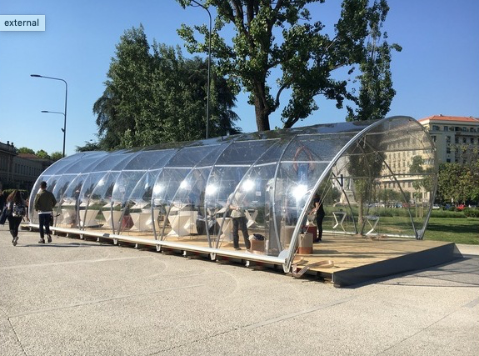
Figure 1: This is a typical figure/photo caption. Obtain permission and include the acknowledgment required by the copyright holder if a figure is being reproduced from another source.

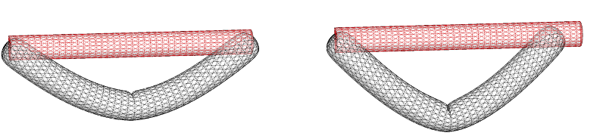
Figure 2: This is a typical figure/photo caption. Please make your diagrams as clear as possible. Obtain permission and include the acknowledgment required by the copyright holder if a figure is being reproduced from another source.

3. Referencing literature
Use the APA citation style (more information here) as shown in the sample reference list at the end of this template. To make it easier for readers to follow reference citations in text, it is recommended that authors refer to previous literature by indicating author(s) surname(s), the year of publication enclosed within parentheses (e.g. Forster 2004 or Monticelli and Zanelli, 2016, Nguyen and al. 2015). The APA style dictates that the references that have been cited in the text should be listed at the end of the paper. Place references in alphabetical order by the surname of the first author followed by the initials of the author’s given name. Arrange references with the same author(s) by year of publication, beginning with the earliest.

4. Conclusion: submission of contributions
Papers should be uploaded to the Symposium submission website by the announced deadline. Submissions should be made in Microsoft Word (.docx) and/or PDF format(s) following the instructions on the submission website.
Authors must also upload the “Copyright Declaration” form provided on the TensiNet Symposium 2023 website.

Acknowledgements
If necessary, of course!

References
Forster B., and Mollaert M. (eds.) (2004), European design guide for tensile surface structures: TensiNet, TensiNet.
Monticelli C., Zanelli A. (2016), Life Cycle Design and Efficiency Principles for Membrane Architecture: Towards a New Set of Eco-design Strategies. In: Procedia Engineering, vol. 155 (pp. 416-425).
Nguyen Q.-T., Thomas J.-C., and Le Van. A. (2015), Inflation and bending of an orthotropic inflatable beam. In: Thin-Walled Structures, vol.88 (pp. 129 – 144).

