Title of your presentation for the TensiNet Symposium 2023
First Author*, Second Author ª, Third Author ^{b}
*First affiliation, Address, City and Postcode, Country, Email Address
ª Second affiliation, Address, City and Postcode, Country
^{b} Third affiliation, Address, City and Postcode, Country

Abstract
This document presents the abstract formatting guidelines for the TensiNet 2023 Symposium and contains information about the desired format of one-page abstracts for single-blind peer review. You can produce your abstract by simply replacing the contents of this file and saving it as a PDF document (pdf file format). Name the file as follows: ts2023_ABSTRACT_Last name First name.pdf. Abstracts must be written in English. They may include text without equations or special characters and no more than 2 figures (see Figures 1 and 2). They should be at least 250 words, one page maximum on A4 paper size.
Please use the Times New Roman 11pt font supplied in this template (Style: Normal). If you do include references, be sure to use the IEEE citation style as shown below. It is recommended that the number of references included in the abstract phase will be limited to three.
To improve the likelihood of your abstract being accepted, it is strongly recommended that it concisely include: a clear description of the problem addressed by the research or project; a contextualization of relevant previous work and how the abstract’s contribution is new and different; a description of the methodology or approach used; and a discussion about the meaning, value, and impact of the results. Careful editing for clarity is also highly recommended.

Keywords: Include a list in 9pt Times New Roman [Style: Keywords] of fewer than ten keywords or terms, separated by commas, using nouns or adjective(s)-plus-noun forms that are relatively standard in the field of lightweight construction. (For example: pneumatic structures, softening, lightweight structures, structural membrane, sustainability, performance, conceptual design, form finding, optimization, manufacturing)

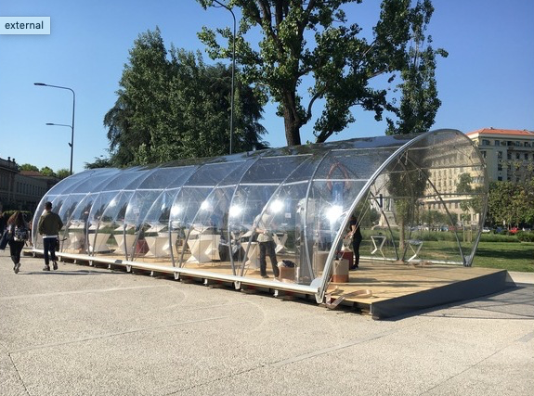
Figure 1: External view of the TempoActive pavillon

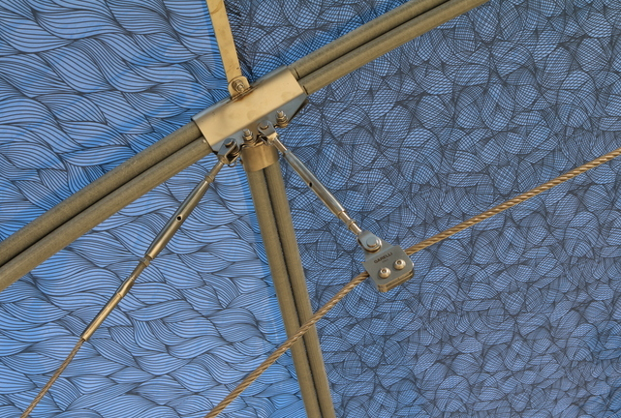
Figure 2: Détails of the TempoActive Pavillon

References
- B. Forster, and M. Mollaert (eds.), European design guide for tensile surface structures: TensiNet, TensiNet, 2004.
- C. Monticelli, A. Zanelli, '" Life Cycle Design and Efficiency Principles for Membrane Architecture: Towards a New Set of Eco-design Strategies," Procedia Engineering, vol. 155, 2016, pp. 416-425.
- Q.-T. Nguyen, J.-C. Thomas, and A. Le Van. “Inflation and bending of an orthotropic inflatable beam”. Thin-Walled Structures, 88 (0), 2015, 129 - 144.

